H.M. Queen Elizabeth II 1926-2022

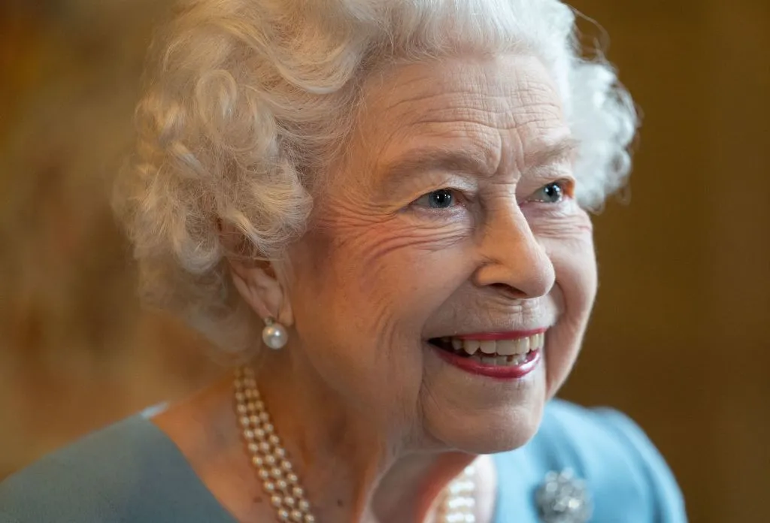

In respect for HM Queen Elizabeth II We will be closed to the public on Monday 19th September.

